*Jahangirnagar University*

*Computer networking Lab*

*Lab-02*



Course Title: Computer Networking laboratory

Course Code: CSE-402

Submitted by:

Name: Farzana Hossain Rumki

Roll: 09

Submission Date : 15-09-2019

**Introduction:**

The existence of hubs is the biggest difference between random networks and scale-free networks. In random networks, the degree k is comparable for every node; it is therefore not possible for hubs to emerge. In scale-free networks, a few nodes (hubs) have a high degree k while the other nodes have a small number of links.

A switch is more intelligent than an Ethernet hub, which simply retransmits packets out of every port of the hub except the port on which the packet was received, unable to distinguish different recipients, and achieving an overall lower network efficiency.

**Description:**

We used cisco packet tracer for simulation. Several computer devices are connected through the routers and different ip addresses were assigned to them. Then a packet is sent through them to check the characteristics of routers.we created a hop table to access networks that are far from the routers to pass the packets.

**Simulation:**

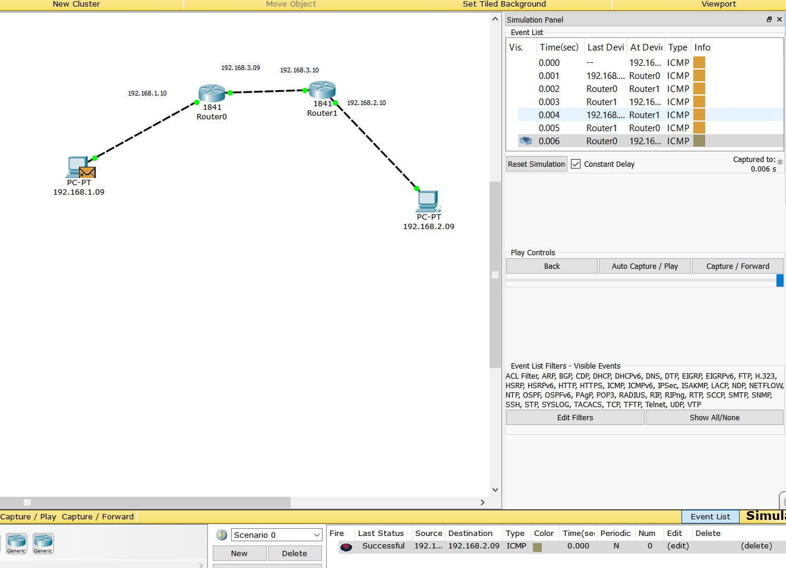

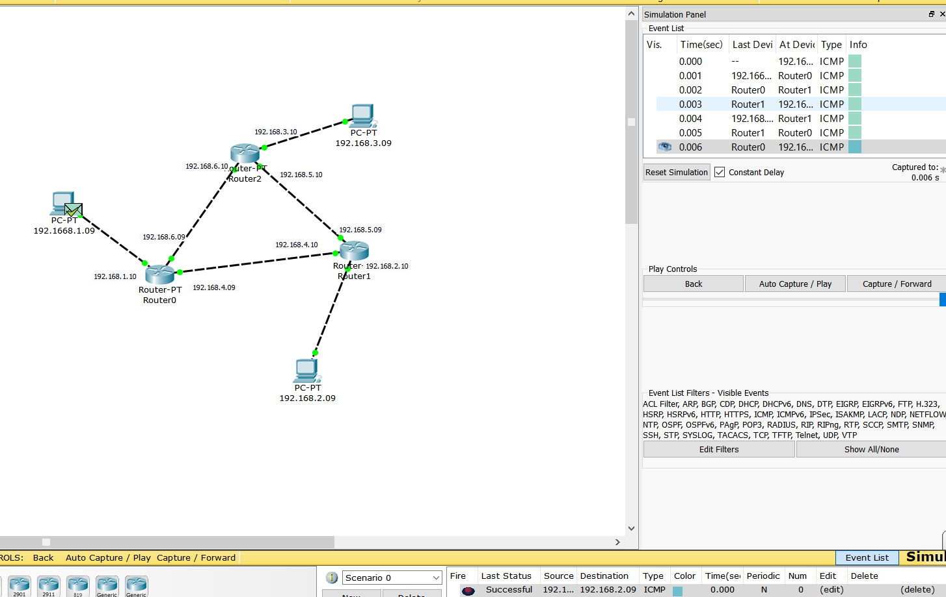

**Result:** We can see that the Routers sends the packet the required path mentioned in the rout table.

**Comment:** Using a table to determine hops is efficient.